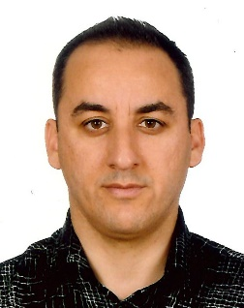

Girne American University
Foundation English School
Curriculum Vitae

I. PERSONAL INFORMATION
Name and Surname | POLAT TANOGLU
Date of Birth & Place | 6/3/1978
Nationality | TRNC
Marital Status | MARRIED
Home Address | RAMIZ TUREN SOK. TANOGLU APT. KYRENIA
Work Address | KARAOGLANOGLU GIRNE AMERICAN UNIVERSITY
Work Phone | 03926502000
E-Mail Address | polattanoglu@gau.edu.tr
II. EDUCATION
Institution |  | Date | Degree | Major Field
GIRNE AMERICAN UNI. |  | 25/6/2016 | MA | ELT
EASTERN MEDITERRANEAN UNI. |  | 22/6/2000 | BA | ELT

III. PROFESSIONAL EXPERIENCE
Institution | Date | Title
GIRNE AMERICAN UNI – FOUNDATION ENG. SCHOOL | 10/4/2006-16/1/2019 | LECTURER
NECAT BRITISH COLLEGE | 01/01/2018-31/07/2018 | LECTURER
IV. Conferences, Seminars, Workshops attended
NA
V. Presentations
NA
VI. Publications
NA
VII. Foreign Languages
ENGLISH
VIII. Other Information
VA
IX. Professional Interests
LANGUAGES, FOREIGN LANGUAGE TEACHING-LEARNING

