Girne American University
Foundation English School
Curriculum Vitae 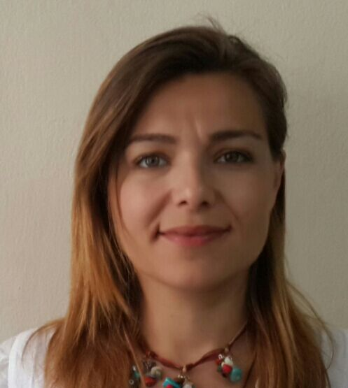

I. PERSONAL INFORMATION
Name and Surname | DILEK TANOGLU
Date of Birth & Place | 19/12/1986 ISTANBUL
Nationality | TRNC
Marital Status | MARRIED
Home Address | RAMIZ TUREN SOK. TANOGLU APT. KYRENIA
Work Address | KARAOGLANOGLU GIRNE AMERICAN UNIVERSITY
Work Phone | 03926502000
E-Mail Address | dilektanoglu@gau.edu.tr
II. EDUCATION
Institution |  | Date | Degree | Major Field
GIRNE AMERICAN UNI. |  | 22/6/2014 | BA | ELT

III. PROFESSIONAL EXPERIENCE
Institution | Date | Title
GIRNE AMERICAN UNI – FOUNDATION ENG. SCHOOL | 1/11/2019-Pres. | LECTURER
IV. Conferences, Seminars, Workshops attended
NA
V. Presentations
NA
VI. Publications
NA
VII. Foreign Languages
ENGLISH
VIII. Other Information
VA
IX. Professional Interests
LANGUAGES, ADULT AND CHILD FOREIGN LANGUAGE LEARNING

