Girne American University
Graduate Institute of Education of Research

THESIS PREPERATION GUIDELINES

FORMATTING
This guideline is intended to help students prepare their thesis manuscripts to an appropriate academic or professional standard. Below are the requirements for the preparation of your thesis.

Print and Paper Quality
Use of laser printers is recommended. Paper size should be A4 size (21 x 29.7 cm), portrait (vertical) orientation. The thesis must be printed on good quality white paper (at least 75 g) on one side of the paper only.

Fonts and Spacing
The text must be typed preferably in Times New Roman 12 pt. font with a margin of 4 cm on the left (the binding side). The remaining margins must be 2.5 cm. wide. Text must be one and a half-spaced, except for quoted sections, references, footnotes, and captions of tables and figures.

Margins and Pagination
The page numbers in the preliminary material are to be in lower case Roman numerals, starting with the approval page that is numbered “ii”. Title page is unnumbered, but is the implied number “i”. First page of Chapter 1 (Introduction) uses the Arabic number “1” and pages thereafter carry consecutive Arabic numbers, including the pages in the Appendices and the References. All page numbers are positioned in the upper right-hand corner and 1.5 cm above the first line within the required margin boundaries.
Print the text so that each page is filled from the top margin to the bottom, adjusting the latter when necessary to avoid "widows" and "orphans." (A "widow" is the first line of a new paragraph at the bottom of the page; an "orphan" is the last line of a paragraph at the top of a page.
Headings
Headings must include three levels: Chapter names are Level 1 headings. Chapter headings must be centered, bold-faced, and capitalized. Sub-headings of a chapter are Level 2 headings. Level 2 headings must be left justified, bold-faced, and must have the first letters of principal words capitalized. Level 3 headings must be left justified, boldfaced, and must have the first letter of the first word capitalized. Subheadings are separated by a space of one line from the following section and by a space of two lines from the previous one. Bullets or itemizations such as (i), (ii) may be used as necessary. Below is an example of the use of headings.

ELEMENTS OF THESES
The Preliminaries
The preliminaries or the front matter consist of any or all of the following sections: title page, approval page, declaration, abstract, dedication (optional), acknowledgements, table of contents, list of tables, list of figures, and abbreviations (if any). Each section should start on a new page.

Binding and cover
The thesis should be bound in navy blue hard cover. The format of the cover page and the spine must be the same as in Appendix 1.

Blank page
A blank page should appear between the cover and the title page.

Title page
The title should contain information that is as clear and to the point as possible. The title itself should be able to stand alone, summarize the main idea of the thesis and if possible, with style. Generally, using words like "An Investigation into" or "A Study of" is not recommended. It should be a concise statement of the main topic and should identify the variables under investigation and the relation between them.
The title must be single-spaced, written in bold and in all capital letters, and should begin at 5 cm (2 inch) from the top of the page. The format of the title page, including spacing and capitalization must be exactly as in the sample title page in Appendix 2.
Approval page
The approval page provides space for the signatures of the examiners and the director of the institute indicating their acceptance of the work as shown in Appendix 3.

Declarations
At the front of the thesis submitted for assessment, students are required to incorporate a signed declaration. The declaration must state:
(a) that the thesis has been composed by the candidate, and (b) either that the work is the candidate's own, or, if the candidate has been a member of a research group, that the candidate has made a substantial contribution to the work, such contribution being clearly indicated, and (c) that the work has not been submitted for any other degree or professional qualification except as specified, and (d) that any included publications are the student’s own work, except where indicated throughout the thesis and summarised and clearly identified on the declarations page of the thesis.
Students must ensure they have signed and dated the declaration page. The signed declaration must also be included in the final version of the thesis.

Abstract
It includes a clear statement of the research problem, a brief description of the methodology, and a summary of the major findings and their significance. Key words (3-5) should appear after the abstract. The Turkish version of the abstract should follow the abstract page of the English version. (For an example please see Appendix 4).

Acknowledgements
This section contains expressions of appreciation for assistance and guidance of those who have helped you in matters scientific, and also indirectly providing such essentials as support, assistance and guidance. (See Appendix 5).

Table of contents
The table of contents should list all the elements of the preliminaries beginning with the abstract page, all the chapter titles, the main headings and subheadings in the text, the reference and appendix pages. The numbering of chapters and the wording, capitalization, and the punctuation of titles and headings should be exactly the same as they appear in the text. (See Appendix 6).
List of tables
Tables should be numbered consecutively in the text and be given a suitable caption. The number and the caption of the tables are placed a space of one line above each table. The captions of tables and figures are centered in relation to the table or figure.
The list of tables, which is presented on a separate page, gives the number and title of each table and the page on which it can be found as shown below.

LIST OF TABLES

Table 4.1. Means and standard deviations of the pilot study…………………………...23
Table 4.2. Means and standard deviations for the experimental and control groups…..26
Table 5.1. Comparison of descriptive statistics of the studies………………………… 45
OR
Table 1. Means and standard deviations of the pilot study…………………...……......23
Table 2. Means and standard deviations for the experimental and control groups…....26
Table 3. Comparison of descriptive statistics of the studies……………………………45

List of figures
The numbers of the figures and their captions are placed a space of one line below each figure. The captions of figures are centered in relation to the table or figure. The presentation of the list of figures is similar to that of the list of tables
LIST OF FIGURES
Figure 3.1. Flow chart of the study ………………………………………………..23
Figure 4.1. Comparison plot means and standard deviations for the experimental
and control group…………………………………………………...….26
Figure 5.1. Comparison of spatio-temporal distribution of the studies……………45
OR
Figure 1. Flow chart of the study ………………………….……………….……….23
Figure 2. Comparison plot means and standard deviations for the experimental
and control group………………………………………………..…...….26
Figure 3. Comparison of spatio-temporal distribution of the studies……….………45

Abbreviations
If there are any abbreviations that are used in dissertations, They should be list and explained here. An example is given below:

LIST OF ABBREVIATIONS
C2R: Case 2 Region Algorithm
OAC: Optically Active Components
IOP: Inherent Optical Properties
AOP: Apparent Optical Properties
TL: Total Length
W: Weight

INTRODUCTION
A good introduction orients the reader to the importance of the problem by providing sufficient background information. The background should
- alert readers‟ interest
- indicate the focus and direction of the thesis, and act as a navigation guide to its reading
- show the reader how you are approaching the question
- provide a context for the main study.
The introduction section covers smoothly and gradually the following sections: the research problem, purpose of the study, formulation of hypotheses, assumptions, definition of terms, and significance of the study. The introduction should end with a summary paragraph and an outline of the remaining thesis chapters.
Statement of the problem
The introduction should provide a general statement of the problem being addressed. This places the thesis in perspective. This leads you to the present problem through a general and brief review of the background literature. Sub-problems, if any, are also described here.
Purpose of the study
This section describes why the research is being carried out. This section involves a description of the reason for the conduct of the study, followed by research questions and hypotheses.
Significance of the study
This section is written in the light of the following questions:
- Why is it important that a study be done on this topic? What new insights would this bring?
- Is it because the results of such a study would provide valuable information needed to solve a certain problem?
- Or would the results open up possibilities for further research?
Hypotheses
A good hypothesis provides a reasonable explanation of a relationship between variables, and defines those variables in measurable terms. The hypothesis is based upon the implications of previous research. Every aspect of the research is affected by the hypothesis. A well-developed hypothesis is testable. It should be possible to accept or reject the hypothesis by collecting and analyzing data. Its confirmation or disconfirmation should contribute to theory or practice.
The following is a hypothesis that examines the effects of commercials on consumer behaviour: "Adolescent boys buy more of the products advertised on television than do adolescent girls."
A good hypothesis is stated in declarative form and not as a question. It posits an expected relationships between variables. The above hypothesis describes the relationship between commercials and consumer behaviour. These variables are being tested to see if one (commercials) has an effect upon the others (gender and the buying behaviour of adolescents).
Assumptions
Assumptions are what the researcher takes for granted. For example, we are attempting to determine by means of a pre-test/post-test whether a particular method of teaching has produced the results hypothesized. A basic assumption in such a situation must be that the test measures what it is supposed to measure. Similarly, if in the definitions section an "outstanding teacher" is operationally defined as one who is nominated for teacher-of-the-year, it is being assumed that the nomination process results in outstanding teachers.
Definition of terms
This section describes the definitions of terms used in the research problem and the hypothesis. The terms must be interpreted in relation to particular context of the research problem, not to the dictionary definitions.
Limitations
The main limitations of the study will be elaborated in the "Recommendations" section. However, this section enables the researcher to describe some immediate limitations following the formulation of the hypothesis.
LITERATURE REVIEW
Unlike the brief literature review described above, which provides a brief and immediate background, context and framework for the research problem, this section explores the relevant literature review in depth. The literature review section focuses on the following questions: "Where did the problem come from?"; "What is already known about this problem?", "What other methods have been tried to solve it?" The literature review analyzes, evaluates and interprets existing research, notes discrepancies, makes criticisms and suggests improvements on previous research.
The literature review allows the researcher to
- identify gaps in the literature
- avoid reinventing the wheel (at the very least this will save time and it can stop you from making the same mistakes as others)
- carry on from where others have already reached
- show the logical continuity between previous and present work
- increase your breadth of knowledge of your subject area
- identify seminal works in your area
- provide the intellectual context for your own work, enabling you to position your thesis relative to other work
- identify opposing views
- demonstrate that you can access previous work in an area
- identify appropriate methods that could be relevant to the thesis.
These all facts can be summarized in two main sub-sections:
- Current Status of the Topic
- Review of Related Empirical
METHOD
The methodology section describes in detail how the research study was conducted. Below are some sub-sections involved.

Research design
This section describes briefly the research design you have employed (e.g. descriptive, survey, experimental).
The following issues need to be addressed here: "Is the research design appropriate for the research problem?; "Does the research design control for threats in internal and external validity of the study?"

Sampling method
This section provides a description of the population from which the samples were selected. It describes the participants involved in the study in the light of the following questions:
- How many participants were involved in the study?
- Who were the participants?
- When and where were they investigated?
- What is their characteristics such as age, sex, education level, socio-economic background, and nationality?
- How were they selected? Randomly or on volunteer basis?
- Did any of the subjects drop-out? If so when, how, and how many?
Data collection procedures
This section first describes, if any, the instruments or materials used in the study. These materials are usually included in the appendices. The following issues need to be addressed here: "Are the data collection instruments described adequately?"; "What is the instrument intended to measure?"; "Is any information related to the reliability and validity of the instrument provided?"
The data collection section should describe each step followed in conducting the study in chronological order and in sufficient detail to permit the study to be replicated by another researcher. This can be achieved by answering the following questions: "What did the subjects do in the study?; "What was done to them?"; "How were the materials prepared, administered and scored?" ; "What were the environmental conditions?" ; "Were the conditions the same for all the participants involved?" ; "How long did the process take?"; "Are there any unforeseen events which might have affected the results?"

Method of data analysis
This section describes how the data were arranged and analyzed in this study, what statistical programs were used, etc.

RESULTS and DISCUSSION
The purpose of the “Results” section is to summarize the results of the data analyses. This section answers the questions raised in the introduction section. For each hypothesis, the statistical test of significance selected and applied to the data is described followed by a statement indicating whether the hypothesis was supported or not supported. Tables and figures are used to present findings in summary or graph form to add clarity to the presentation. Tables present numerical data in rows and columns and usually include descriptive statistics, such as the means and standard deviation, and the results of test of significance.
While the “Results” section is a technical report of what happened in the study, the “Discussion” section is to examine, evaluate and interpret the results as well as to draw implications about them. In this section you will find clear, unambiguous and direct answers to your original questions set in the introduction section. This section also explains why the results were as they were. Another step in this section is to tie your findings in with the relevant literature, most of which you will have cited in the introduction. Similarities and differences between your results and the work of others should clarify and confirm your discussion. If your results are not consistent with your original hypothesis you should suggest an explanation for these discrepancies. Present the most probable explanations first and the least probable last.
You should also be able to comment on the following issues in this section:
"What have I contributed here?”;
"How has my study helped to resolve my original problem?";
"What theoretical and practical implications can I draw from my study?".

Conclusions and Recommendations
This section is the last part of the body of the thesis. This section is explained in the following sub sections.

Conclusions
Conclusions are not a summary of the thesis; They helps to organize these as short numbered paragraphs, ordered from most to least important. All conclusions should be directly related to the research question.
In the "Conclusions", you should present a summary of the findings and repeat the major conclusions reached in the discussion. They are short, concise statements of the inferences that you have made to explain what your study does and does not demonstrate. Note that no new conclusions may be inserted in this section. All the conclusions reached here must have been the object or the results of the argumentation in the "Discussion" chapter.
Recommendations
This section is used to make recommendations for future research and/or future action. You may propose additional research that should be done on the problem. Any limitations, if any, could be related to the proposal for future research. Avoid clichés such as "Additional research on this problem is needed before definitive conclusions can be reached". Instead be specific about what research should be done and why it needs to be done.

REFERENCES
Referencing is a standardized method of acknowledging sources of information and ideas that you have used in your thesis. Referencing is necessary to avoid plagiarism, to verify quotations, and to enable readers to follow-up and read more fully the cited author‟s arguments. Most of the references should be from scholarly research journals rather than popular magazines, textbooks, or theory books.
There are many forms of referencing. The APA (American Psychological Association) system is the accepted referencing style.
The APA system of referencing uses the author-date method of citation. It consists of two elements:
(1) in-text citations (also known as in-text references) giving author, year and sometimes page number in the body of the paper
(2) a reference list at the end of the paper providing the complete details for each in-text citation.
Part 1 deals with in-text citations. It gives examples of a range of common types of sources that you are likely to use in your theses.
Part 2 deals with presenting the related reference list entries for the in-text citations provided in Part 1.

In-text citations
Citing a work by one author
When you refer to a single author, include the author‟s family name and year of publication, using one of the forms shown here.
• Clay (2003) argues that having a planned approach to writing essays can be of great benefit.
or
• Essay writing can be made much more manageable if a planned approach is taken (Clay, 2003).

Repeated citations of a study within one paragraph
In any one paragraph, if you cite a particular reference more than once, include the year only the first time. In subsequent citations in the same paragraph you need only the family name, provided studies cannot be confused. (This also applies to a citation with any number of authors.)
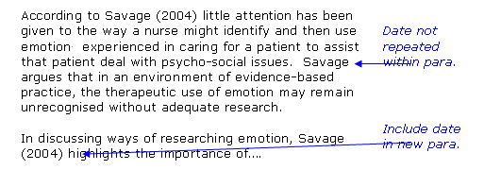
Citing a work by two authors
Again, include the family name of both authors and year each time - except where there is a repeated citation in the same paragraph, as noted earlier.
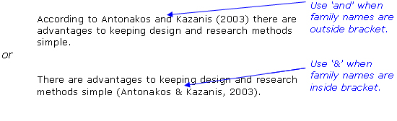
Citing a work by three, four or five authors
In these cases, cite all authors the first time, then in subsequent citations of this work use the family name of the first author plus „et al.‟ and the year, as shown below.
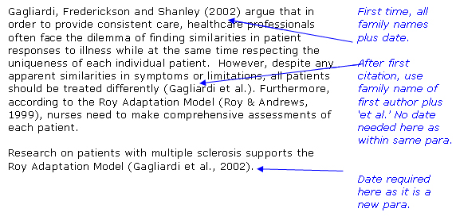

Citing a work by six or more authors
Use only the family name of the first author plus „et al.‟ in all citations including the first. Use date as appropriate according to the rules above.
Mahon et al. (1997) reviewed how nursing diagnosis content is presented in nursing textbooks.
In the reference list, however, provide the family name and initials of the first six authors, and shorten any remaining authors to „et al.‟

Citing from secondary sources
That is, you read one author (secondary) who cites another (primary). In the example that follows, you have read Savage who referred to a 1998 publication by Lupton, but you did not read Lupton yourself.
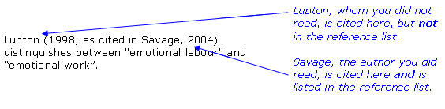

Citing an author from an edited book
That is, a book that consists of chapters or articles written by different authors. You need to acknowledge the author of the chapter or article you used. This author is cited in text (that is, in the body of the paper) in the same way as for one, two, three or more authors, as shown earlier.
In the example below, Naidoo has written a chapter in a book edited by Thorogood and Coombes. In the body of your assignment cite only Naidoo.
Naidoo (2000) claims that risk factor simulation models...

Citing multiple works published in the same year by the same author
Use a/b etc. to differentiate between works in same year and order alphabetically by title in the reference list.
In-text citation: In recent reports (Napier, 1993a, 1993b)...
In the reference-list:
Napier, A. (1993a). Fatal storm. Sydney: Allen & Unwin.
Napier, A. (1993b). Survival at sea. Sydney: Allen & Unwin.
Citing multiple works by the same author
Such citations are ordered by the year of publication, starting with the earliest, both in text and the reference list.
In-text citation:
Brown (1982, 1988) has indicated that...
In the reference-list:
Brown, P. (1982). Corals in the Capricorn group. Rockhampton: Central Queensland University.
Brown, P. (1988). The effects of anchors on corals. Rockhampton: Central Queensland University.
Citing multiple works by different authors
If two or more authors are cited at the same point in the text then they are included in the same in-text citation, separated by a semicolon
e.g. (…….. Brown 1991; Duff 2005; Smith 2003). They are presented alphabetically not chronologically.
Group or corporate authors
Where the author is a government agency, association, etc. that has a familiar or easily understandable acronym, it as cited as follows:
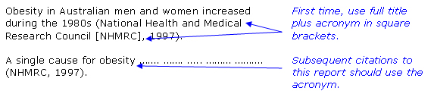
The entry in the reference list is under National Health and Medical Research Council.
No date
In-text citation:
Brown (n.d.) explains that .....
Reference list:
Brown, F. (n.d.). Obesity. Retrieved May 12, 2004, from http://www.geocities.com/nutriflip/Diseases/Obesity.html
No author
(1) If the author is designated as „Anonymous‟, use the word „Anonymous‟ in the in-text citation and in the related reference list entry.
Health-care systems are in need of ….. ………. ……. (Anonymous, 2001).
(2) If no author is designated, cite in text the first few words of the reference list entry (which is usually the title) and the year. Full title details are provided in the reference list entry.
Studies suggest that ………………… (Motivation Study, 2005).
The APA citation for articles is different from that for books. However, this guide does not make such a distinction for ease of use
Translated works
In text citations should appear with both dates of original publication and translated work:
…… (Eco, 1986/2007).
Quotes
Short quotes (fewer than 40 words) should run on as part of your sentence with double quotation marks to signal where the quote starts and finishes. The page where the quote comes from must be included.

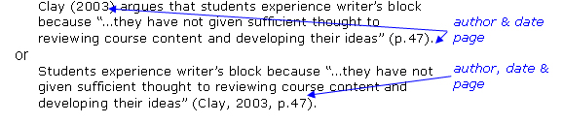
Long quotes (more than 40 words), known as block quotes‟ should:
- start on a new line,
- be indented 5 spaces from the left hand margin,
- be single-spaced (different from the APA style),
- omit quotation marks as shown in the example below,
- be followed by the parenthetical citation after closing punctuation mark.
The following is an example of formatting long quotations:
An important stage in thesis writing is planning. Clay (2003) comments that:
Some students are tempted to plunge into writing their assignment, beginning with the introduction, but soon find that they experience “writer‟s block” and cannot decide what to write next. The problem occurs because they have not given sufficient thought to reviewing course content and developing their ideas about relating the theory to their practice. (p. 47)
There are a variety of ways that students can plan…

A note about quoting from the Internet...
• Most online articles are pdf files, i.e. copies of print documents, so they usually indicate page numbers. Use these page numbers when you cite your quotation.
• Some articles are not pdf and do not have page numbers. In these cases use paragraph numbers if these are provided.
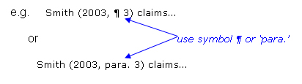
• If paragraph numbers are not provided, either count the paragraphs and use this or if there are subheadings use these and the paragraph number.

General forms and examples
The examples that follow are of the kinds of sources you are most likely to have to use. Check the APA manual for other forms. Note, the examples are separated and placed under subheadings here to show each form. In a reference list, however, they would be all together in alphabetical order with no subheadings and no numbers. See the sample reference list at the end of this resource.
i. Book (One author)
Author, B. (Year). Title of book. City: Publisher.
Nolan, P. (2005). Communication and style. London: Trembly.
More than two authors
Author, A., & Author, B. (Year). Title of book. City: Publisher.
Crawford, P., Brown, B., & Nolan, P. (1998). Communicating care: The language of nursing. Cheltenham: Stanley Thornes.
ii. Chapter or article in an edited book
Author, A., & Author, B. (Year). Title of chapter. In C. Editor & D. Editor (Eds.), Title of book (pp. xx-xx). City: Publisher.
Naidoo, B. (2000). Evaluating the use of public health risk factor simulation models. In M. Thorogood & Y. Coombes (Eds.), Evaluating health promotion: Practice and methods (pp. 99-109). Oxford: Oxford University Press.
iii. Journal article
Author, A., & Author, B. (Year). Title of article. Title of Periodical, volume number (issue number), page numbers.
(The issue number is given only if each issue of a journal begins on page 1.)
Antonakos, C. L., & Kazanis, A. S. (2003). Research process in the health sciences: A focus on methods. Research and Theory for Nursing Practice, 17, 257-264.
Clay, G. (2003). Assignment writing skills. Nursing Standard, 17(20), 47-52.

iv. Newspaper article, authored
Author, A. (year, month day). Title of article. Title of Newspaper, p. x.
Wroe, D. (2004, June 24). Canberra enlists GPs in war on smoking. The Age, p. 3.

v. Newspaper article, no author
Title of article. (year, month day). Title of Newspaper, p. x.
Embryo study nod, OK say IVF couples. (2004, May 31). Herald Sun, p.10.

vi. Author designated as ‘Anonymous’
Anonymous. (Year). Details of the work as appropriate to its form.
Anonymous. (2001). Meeting health-care needs. London: Longman.

vii. Group as author
Organisation Name. (Year). Details of the work as appropriate to its form.
National Health and Medical Research Council. (1997). Acting on Australia’s weight: A strategic plan for the prevention of overweight and obesity. Canberra: Australian Government Publishing Service.

viii. Six or more authors
(Provide family names and initials of the first six authors and shorten any remaining authors to „et al.‟)
Author, A., Author, B., Author, C., Author, D., Author, E., Author, F., et al. (Year). Details of the work as appropriate to its form.
Mahon, S. M., Spies, M. A., Aukamp, V., Barrett, J. T., Figgins, M. J., Meyer, G. A., et al. (1997). Presentation of nursing diagnosis content in fundamentals of nursing textbooks. Nurse Educator, 22(1), 17-22.
ix. Internet document, no author, no date
(If a document has no author or date, begin the reference list entry with the title and use the abbreviation n.d. - no date.)
Title of document. (n.d.). Retrieved month day, year, from web address
Obesity. (n.d.). Retrieved May 12, 2004, from http://www.geocities.com/nutriflip/Diseases/Obesity.html

x. Article in Internet-only journal, authored, not from database
(In an Internet-only journal, page numbers may not be provided and volume and issue numbers are often not relevant. In the reference list entry, provide the details you can determine.)
Author, A. (Year, month day). Title of article. Title of Journal, volume number (issue number), page numbers. Retrieved month day, year, from web address
Rego, P. (2003, August). Confronting embodiment. Nuritinga, 5, 1-6. Retrieved June 20, 2004, from http://www.healthsci.utas.edu.au/tson/nuritinga/issue5/confronting_embodiment.pdf

xi. Electronic copy of a journal article, authored, from database
Author, A. (Year). Title of article. Title of Journal, volume number (issue number), page numbers. Retrieved month day, year, from database name.
Elder, R., Neal, C., Davis, B. A., Almes, E., Whitledge, L., & Littlepage, N. (2004). Patient satisfaction with triage nursing in a rural hospital emergency department. Journal of Nursing Care Quality, 19(2), 263-268. Retrieved June 30, 2004, from Academic Search Premier database.

xii. Translated book
Author, B. (Year). Title of book. (B. Translator, Trans.). City: Publisher. (Date of original publication date.)
Demidov, V. (1986). How we see what we see. (A. Repyev, Trans.). Moscow: Mir Publishers. (Original work published 1986.)

xiii. A thesis
Author, A. (Year). Title of thesis, Unpublished master`s/doctoral thesis. University.
Begg, N. M. (2001). Motivation in the classroom. Unpublished master`s thesis. University of Sydney.

xiv. Conference proceedings
Published
Author, A. (Year). Title of paper. In A. Editor & B. Editor (Eds.), Proceedings of the Conference Name (pp. xx-xx). City: Publisher.
Powell, J. (2006).Higher education in a steady state. In R. Smıth & S. Brown (Eds), Proceedings of the Third Annual Conference of Sydney University (pp. 34-46). Sydney: HERDSA.

Unpublished
Author, A. (Year, Month). Title of paper. Paper presented at the Conference Name, Conference Location.
Cutler, F. (2005, July). Patient satisfaction in hospitals. Paper presented at the 6th Annual Health Conference, Macquarie University, Sydney.

xv. An entry in an encyclopedia or a dictionary
Author, A. (Year). Title of entry. In Title of encyclopedia (Vol. x, pp. xx-xx). City: Publisher.
Bergmann, P. G. (1993). Relativity. In The new encyclopedia britannica (Vol. 26, pp. 501- 508). Chicago: Encyclopedia Britannica.

xvi. Films and video recordings
Author, A. (Producer), & Author, B. (Director). (Year). Title of Movie [Motion picture]. Country: Company
Smith, J.D. (Producer), & Smithee, A.F. (Director). (2001). Really Big Disaster Movie [Motion picture]. United States: Paramount Pictures.

xvii. Brochure
Name of Institute. (Year). Title of brochure. (Edition) [Brochure]. Author`s surname, Initial: Author.
Research and Training Center on Independent Living. (1993). Guidelines for reporting and writing about people with disabilities (4th ed.) [Brochure]. Lawrence, KS: Author.

2.7.3. Creating a reference list
The purpose of the reference list is to enable readers to locate sources. Therefore details must be correct and complete. Each in-text citation and the related reference list entry should be identical in spelling and year. A work is listed only once in the reference list, regardless of how many times it is cited in text. Works not cited in the text should not appear in the reference list.
In compiling your reference list, you should:
- list references on a new page with a centred heading titled „REFERENCES‟
- include books, journal articles, online sources etc. in one alphabetical listing
- order entries alphabetically by family name of author
- list works with no author under the first significant word of the title
- indent 2nd and subsequent lines of each entry (5 spaces)
- use single spacing and have a space of one line between each reference (This differs from the APA style)
- use & rather than `and` to separate different authors
- arrange references that have the same first author and different second and/or third authors alphabetically by the last name of the second author, or the last name of the third if the first and second authors are the same. For example:
Wegener, D. T., Kerr, N. L., Fleming, M. A., & Petty, R. E. (2000). Juror judgments. London: Blackwell.
Wegener, D. T., Petty, R. E., & Klein, D. J. (1994). Attitude change. London: Blackwell.

- When an author appears both as a sole author and, in another citation, as the first author of a group, list the one-author work first. For example:
Berndt, T. J. (1999). Friends` influence on students` adjustment to school. Psychology. Today, 34, 15-28.
Berndt, T. J., & Keefe, K. (1995). Friends` influence on school behavior. Child Development, 66, 1312-1329.

Sample reference list:

REFERENCES

Anonymous. (2001). Meeting health-care needs. London: Longman.
Antonakos, C. L., & Kazanis, A. S. (2003). Research process in the health sciences: A focus on methods. Research and Theory for Nursing Practice, 17, 257-264.
Bergmann, P. G. (1993). Relativity. In The new encyclopedia britannica (Vol. 26, pp. 501- 508). Chicago: Encyclopedia Britannica.
Clay, G. (2003). Assignment writing skills. Nursing Standard, 17(20), 47-52.
Crawford, P., Brown, B., & Nolan, P. (1998). Communicating care: The language of nursing. Cheltenham: Stanley Thornes.
Curtin, E. (n.d). Communicating in a healthy way. Retrieved May 12, 2007, from http://www.geocities.com/communication/examples/com.html
Cutler, F. (2005, July). Patient satisfaction in hospitals. Paper presented at the 6th Annual Health Conference, Macquarie University, Sydney.
Demidov, V. (1986). How we see what we see. (A. Repyev, Trans.). Moscow: Mir Publishers. (Original work published 1986.)
Elder, R., Neal, C., Davis, B. A., Almes, E., Whitledge, L., & Littlepage, N. (2004). Patient satisfaction with triage nursing in a rural hospital emergency department. Journal of Nursing Care Quality, 19(2), 263-268. Retrieved June 30, 2004, from Academic Search Premier database.
Gagliardi, B. A., Frederickson, K., & Shanley, D. A. (2002). Living with multiple sclerosis: A Roy Adaptation Model-based study. Nursing Science Quarterly, 15(3), 230-236.
Mahon, S. M., Spies, M. A., Aukamp, V., Barrett, J. T., Figgins, M. J., Meyer, G. A., et al. (1997). Presentation of nursing diagnosis content in fundamentals of nursing textbooks. Nurse Educator, 22(1), 17-22.
Naidoo, B. (2000). Evaluating the use of public health risk factor simulation models. In M. Thorogood & Y. Coombes (Eds.), Evaluating health promotion: Practice and methods (pp. 99-109). Oxford: Oxford University Press.
National Health and Medical Research Council. (1997). Acting on Australia’s weight: A strategic plan for the prevention of overweight and obesity. Canberra: Australian Government Publishing Service.
Obesity. (n.d.). Retrieved May 12, 2007, from http://geocities.com/nutriflip/Obesity.html
Powell, J. (2006).Higher education in a steady state. In R. Smıth & S. Brown (Eds), Proceedings of the Third Annual Conference of Sydney University (pp. 34-46). Sydney: HERDSA.
Rego, P. (2003, August). Confronting embodiment. Nuritinga, 5, 1-6. Retrieved June 20, 2004, from http://www.healthsci.utas.edu.au/ tson/nuritinga/issue5/embodiment.pdf
Savage, J. (2004). Researching emotion: The need for coherence between focus, theory and methodology. Nursing Inquiry, 11, 25-34.
Wroe, D. (2004, June 24). Canberra enlists GPs in war on smoking. The Daily Mirror, p. 3.

Footnotes and Endnotes
Either footnotes or endnotes can be used. Footnotes appear at the foot of a page, and endnotes appear as a separate page following the references section under the centered heading "ENDNOTES". Footnotes and endnotes can be distracting if they are too numerous and frequent.
Footnote references shall be indicated in the text by an Arabic number placed superior to the text and immediately following the word, phrase or sentence which the footnote concerns, but after any punctuation following the previous word; i.e. "last word.”3 but not "last word”3. Footnotes are indented from the margin line of the text by one centimeter and placed under a broken line made of 20 characters (5 cm). Footnotes are single-spaced and 12 points. Footnotes placed on the same page should be separated by one line. Footnote referencing shall follow the same format as the referencing system used in this guide.

Appendices
This section is used to present information that would not properly fit into the text as it would break up the flow. Appendices include information and data pertinent to the study which either are not important enough to be included in the main body of the report or are too lengthy. The information provided should be necessary and complete. Appendices contain such entries as materials especially developed for the study such as questionnaires, observation scales, cover letters, raw data, data analysis sheets.
Below are some issues for the use of appendices:
- If you have more than one appendix, use numbers to label them (i.e. APPENDIX 1, APPENDIX 2 and so forth)
- Give each appendix an appropriate title
- Place one specific kind of information in each appendix
- Begin each appendix on a new page
- Refer to each appendix in the body of the document.

APPENDICES
APPENDIX 1. COVER PAGE

APPENDIX 2: TITLE PAGE
APPENDIX 3: APPROVAL PAGE

APPENDIX 4: SAMPLE ABSTRACT
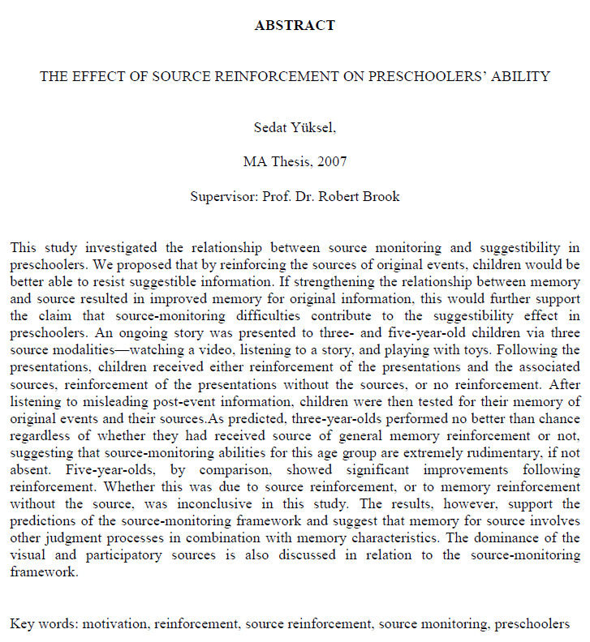

APPENDIX 5: ACKNOWLEDGEMENTS

APPENDIX 6: TABLE OF CONTENTS

